**User Interface V1.6 test report**

## 1. overview

Newly added functions are as shown in the red blocks below.

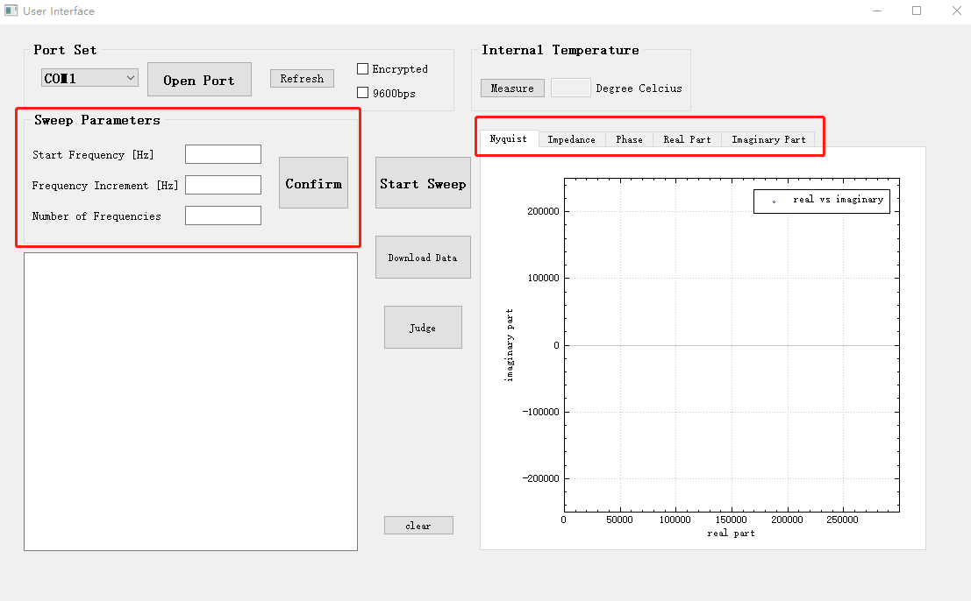

## 2. Send ‘Sweep parameters’ to PCB

For example, after connecting to the PCB, input 1000/1000/100 to ‘start frequency/frequency increment/number of frequency’, then click ‘Confirm’. The results are as follows.

In ‘3’, details of the set frequencies. For now, number of frequencies can only be set lower than 150.

设置开始频率、频率增量和频点数，点击confirm后这些参数将被发送致下位机，即（0x03）；

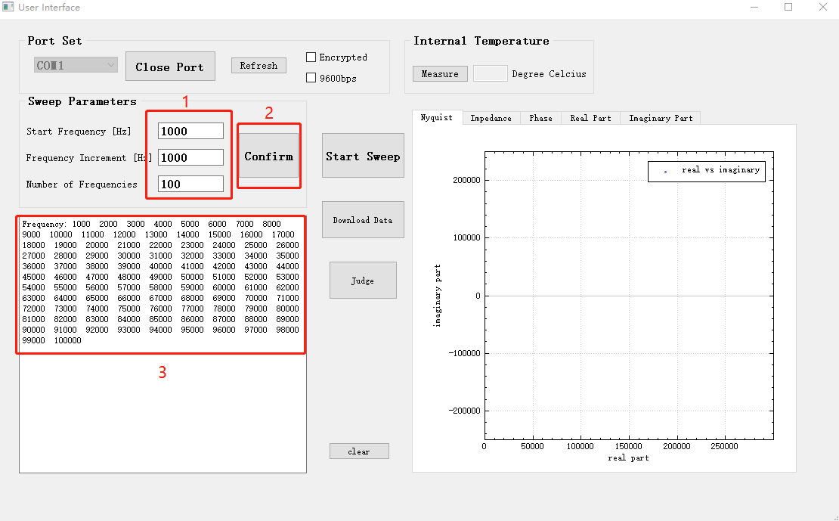

The received data in PCB.



## 3. Send ‘Start Sweep’ to PCB

点击‘Start Sweep’后，上位机告诉下位机要采集校准后的数据，即（0x06）

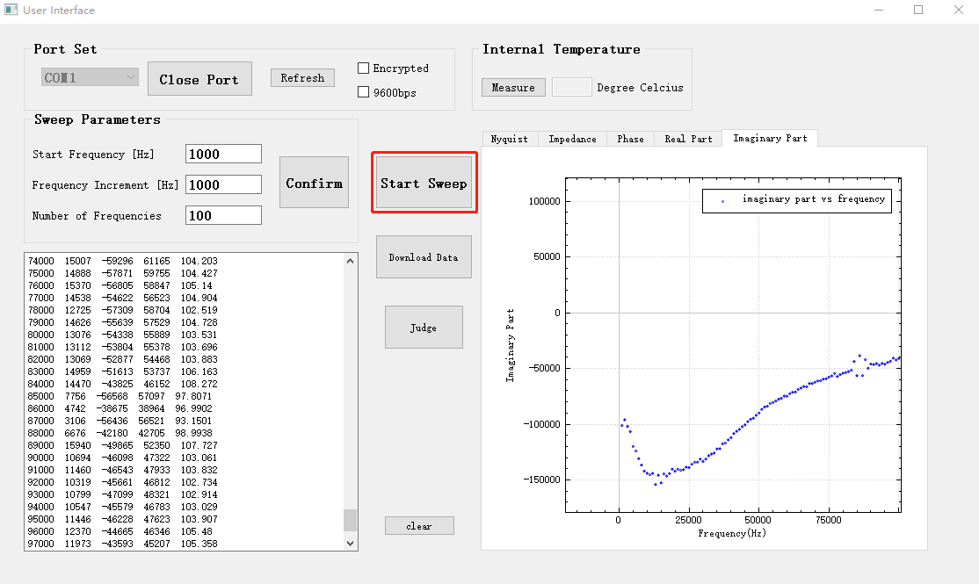

Click ‘Start Sweep’, then after a while, data will be received and plotted.

When clicked ‘Start Sweep’, PCB should receive this following data.



## 3. Plotting function

Now we have Impedance, Phase, real part of impedance and imaginary part of the impedance calculated, shown and saved after receiving them from PCB.

Text box and Nyquist plot

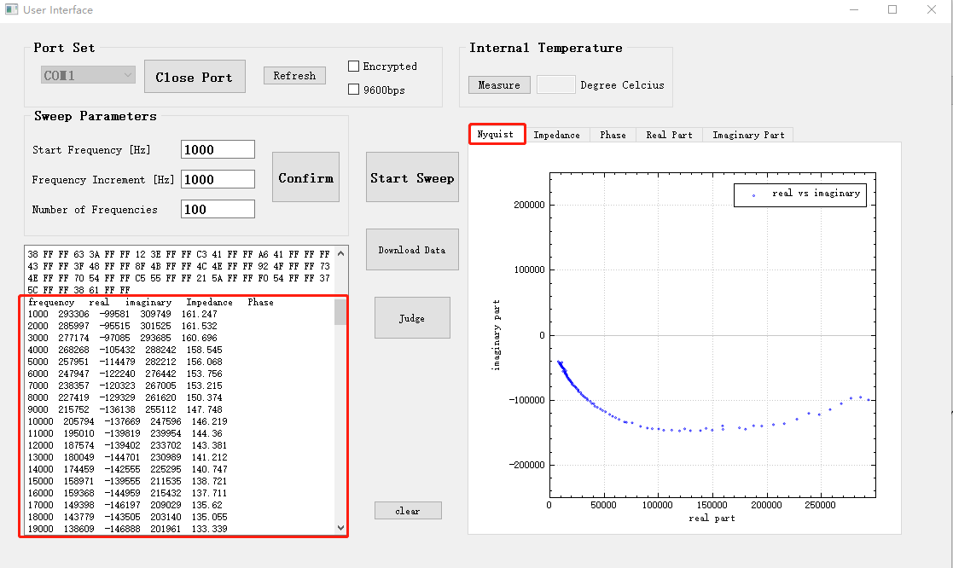

Impedance plot

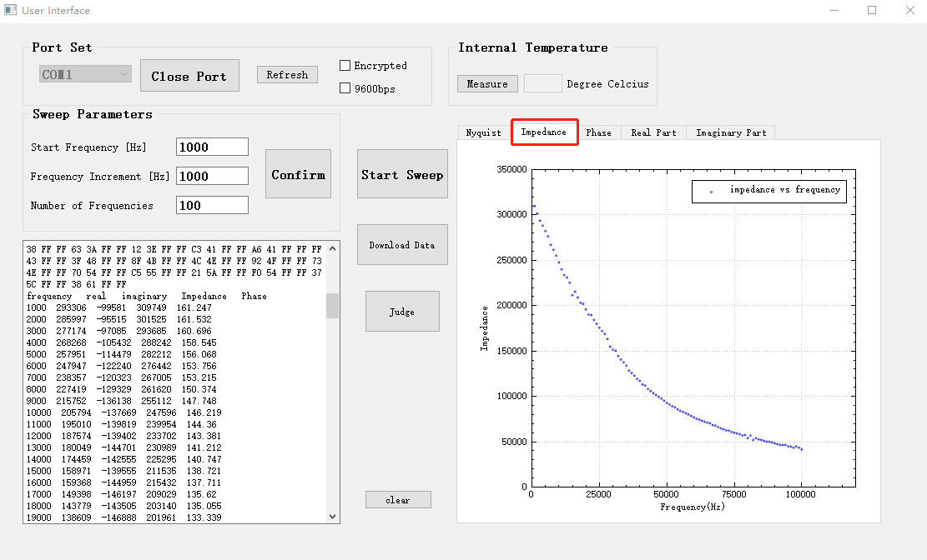

Phase plot

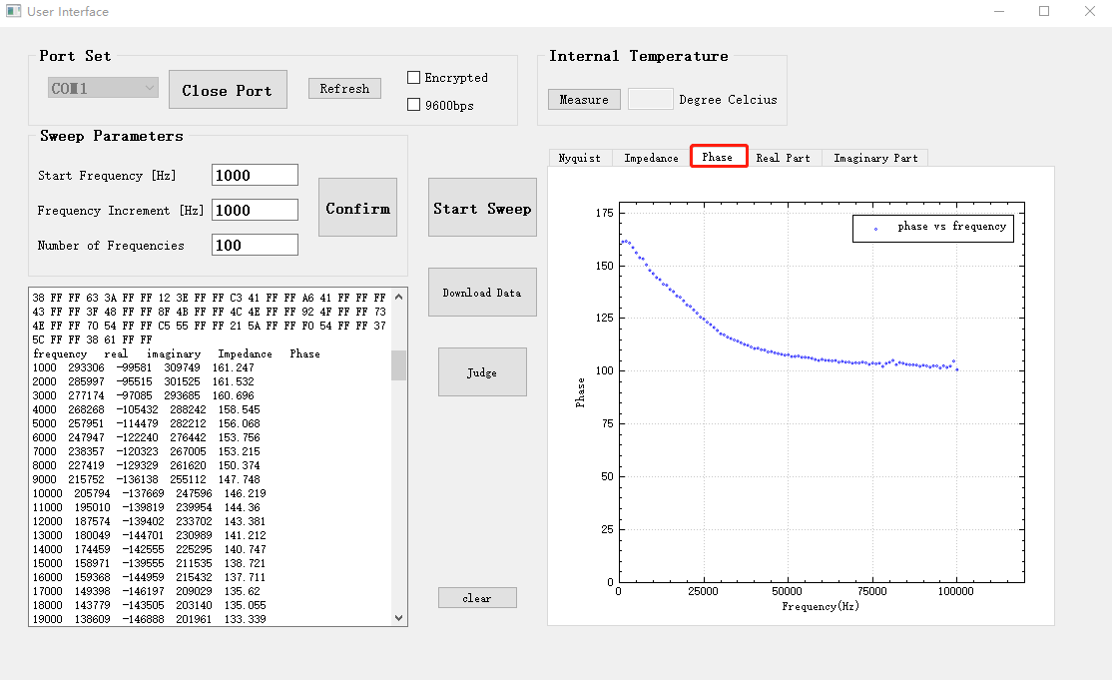

Real part

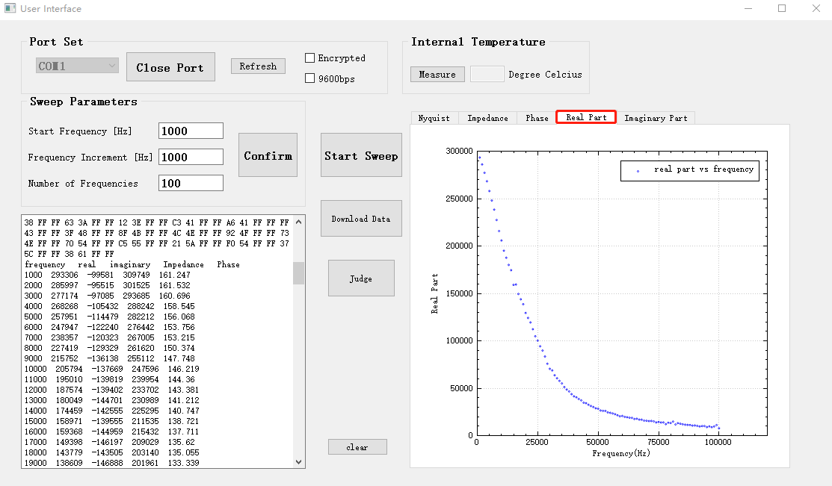

Imaginary part

